**THE LONG-TERM EFFECTS OF AFRICA’S SLAVE TRADES**

Nathan Nunn

Replication Exercise

Francesca Eustacchi, Manvi Jindal, Noor Khoso

The report should i) explain how you go about the replication, and discuss differences between your findings and those in the original paper, as well as limitations of the analysis in the original paper; ii) the application of the new method, which should include a brief description of the method and a discussion of the application of the new method. Code should be attached. Approximate length: 15 pages.

**1. Introduction**

The aim of Nathan Nunn paper is to understand if Africa’s underdevelopment can be partially explained by slave trades, that characterized Africa’s history from 1400 to 1900. The underlying idea is that slave trades affected political stability, states’ strength, and increased the institutional corruption. Also, it augmented the ethnic fragmentation, insecurity, and it discouraged the realization of large communities. All these aspects have been proved to be related to the subsequent economic performance of a country (Bockstette, Chanda, and Putterman 2002; Chanda and Putterman 2005). **🡪 DO WE WANT TO ADD OTHER POTENTIAL REASONS? I THINK WE SHOULD BY THEN SAYING THAT WE COULD NOT MEASURE IT**

**2. Data available**

The dataset used for this paper is quite complex. The author focuses on the total number of slaves taken from each country between 1400 and 1900, as to account for the salves trades related to the procurement of slaves. Specifically, he considers two types of data: the shipping data and the ethnicity ones. For the first type, he takes advantage of the updated version of the Trans-Atlantic Slave Trade Database built by Eltis et al. (1999) and data from Austen (1979,1988, 1992). With this data, the author can calculate the number of shipped slaves from each coastal country, without knowing if their origin was an inland region. To do that, the author considers other mixed sources of data reporting the ethnicity of slaves. **[🡪 DO WE WANT TO ALSO EXPLAIN HOW HE COMBINES THEM AND WHICH ARE THE THREATS OF THIS PROCEDURE?**]. The author ends up with estimated for the number of slaves shipped from each country in Africa during the time periods: 1400-1599, 1600-1699, 1700-1799, 1800-1900.

**3. Methodology**

**3.1 OLS Estimates**

First of all, we started analysing the relationship between past slave exports and current economic performance, which is shown in figure I. The natural log of the number of slave exports has been normalized by land area and it has been plotted against the natural log of the GDP in 2000.

Figure I

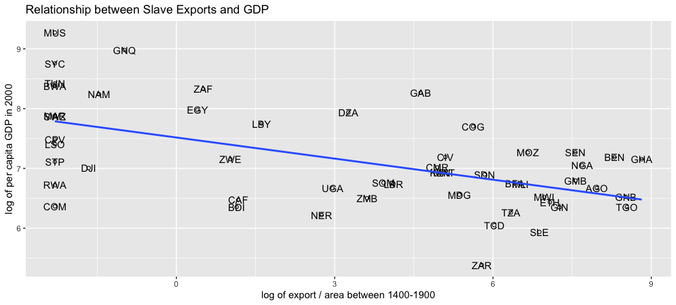

From the figure it is evident that a relationship does exist. As a consequence, we continued the replication exercise by further analysing this relationship through an OLS model and by controlling for other country characteristics that could impact the current economic performance, which is the variable of interest. The equation provided by the author and that we replicated is given by:

$$ln y_{i}=β_{0}+β_{1} ln({exports}_{i}/{area}_{i})+C_{i}^{'}δ+X_{i}^{'}γ+ε_{i}$$

where $C_{i}$ is here a dummy variable representing the origin of the colonizer prior to independence, and $X_{i}$ to account for differences in geography and climate. In Table I the results of this estimate have been reported.

Table I

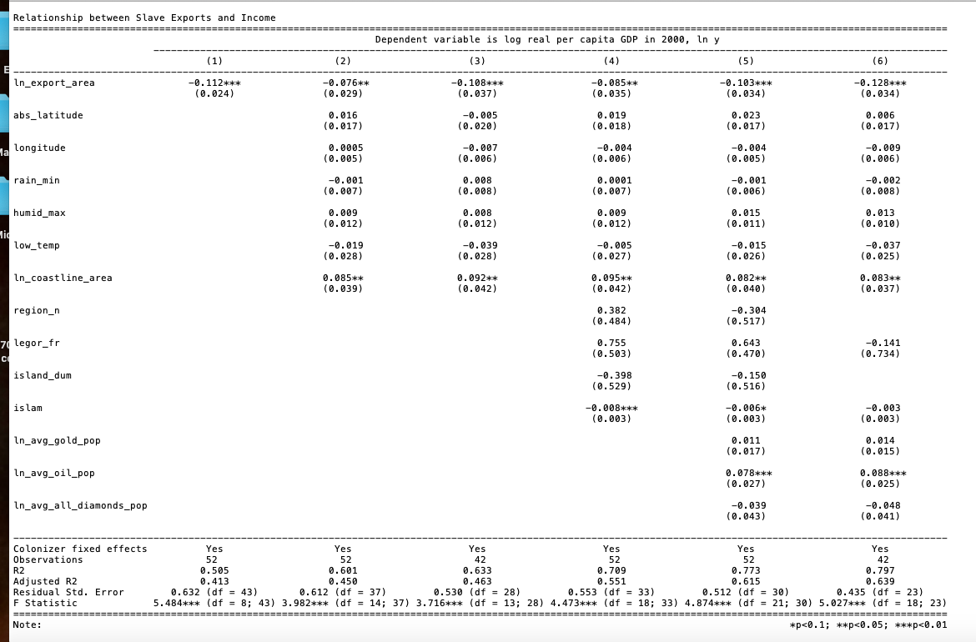

In column (I) we can see the colonizer fixed effects. In column (II) some geography measures have been included as they are expected to influence the climate of the country and thus its economic performance (Karmarck, 1976; Sachs et al. 2001). In column (III) the author decides to omit small islands and North African countries (Marocco, Algeria, Tunisia, Libya, Egypt, Seychelles, Mauritius, Comoros, Sao Tomé and Principe, as they are expected to bias the estimate. Our main coefficient of interest remains significant and negative. In column (IV) the author also includes additional controls to take into account the predominance of the Islamic religion in North Africa and the presence of the French Civil Law, and adds North Africa and Islands fixed effects. Lastly, in column (V) and (VI) he adds control variables to take into account the different endowments of natural resources. Overall, we can observe that the impact of slave trades on the economic performance is significant and negative.

At this point, we decided to add an additional step to the analysis with respect to what the author did. In fact, we considered important to also account for heteroskedasticity-robust standard errors **[🡪 SOME THEORY TO ADD ON WHY WE DO THINK SO**]. Table II reports the results.

Table II

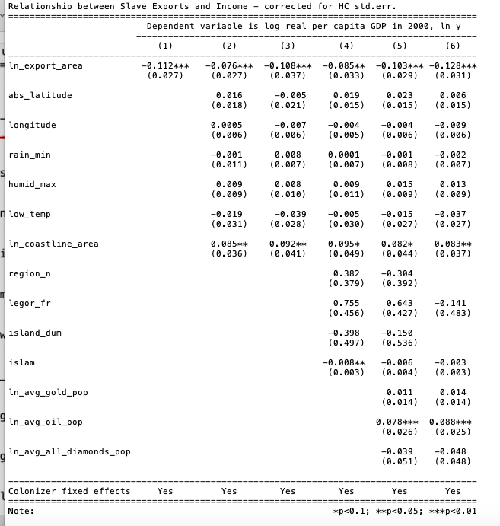

As we can see, the coefficient of interest remains significant and negative.

**3.2 Checking selection into the salves trades**

At this point of the analysis, the author evidences that there could be the possibility for selection into the slaves trades: so that those societies which were underdeveloped selected into slave trades and continued being underdeveloped later. As a proxy of economic development the author uses population density, as suggested by Acemoglu, Johnson, and Robinson (2002), and then he plots the relationship between the log of population density in 1400 and the measure of slave exports used in the previous analysis, thus ln(exports/area).

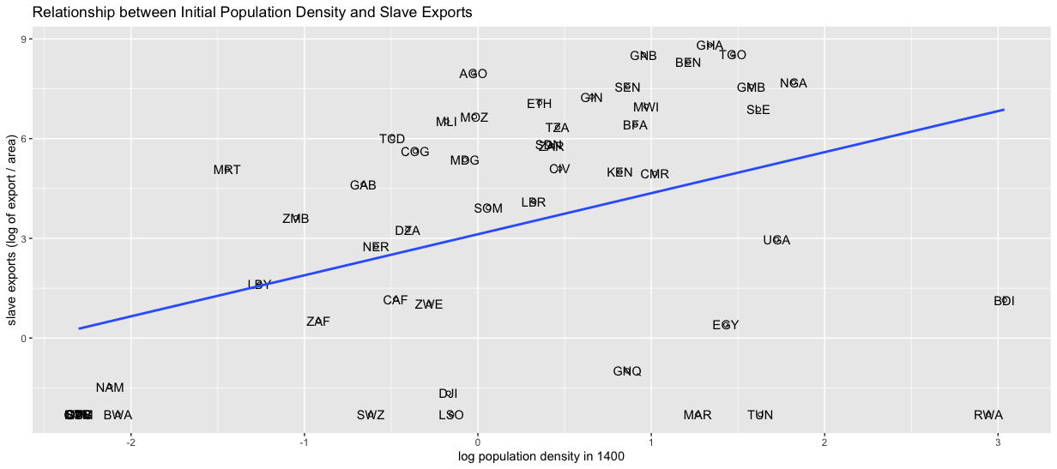

Figure II confirms that there is a relationship between the economic prosperity of a country and slave trades, but it indicates that those more prosperous were those characterized by higher slave exports, which is different from what the OLS estimates were suggesting. As a consequence, we can reasonably assume that the relationship we found with the OLS model is not due to selection.

**3.3 Instrumental variables approach**

At this point, the authors decided to follow a IV approach because [**CAN YOU GUYS EXPLAIN WHY? I DID NOT UNDERSTAND HIS EXPLANATION AT PAGE 159, LAST PARAGRAPH**].

The instrument the author choses is the distance of the locations where slaves where demanded to each African country. In support of this assumption, the author affirms that historically, it has been shown that the location of supply had not an impact on the location of demand and thus the instrument should be valid. He introduces four instruments: sailing distance (a), sailing distance (b), overland distance (a), overland distance (b). The estimates of the new model with the instruments are reported in Table III.

Table III

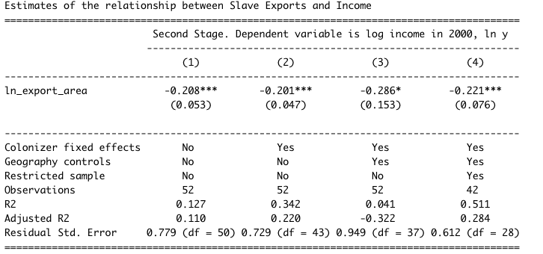

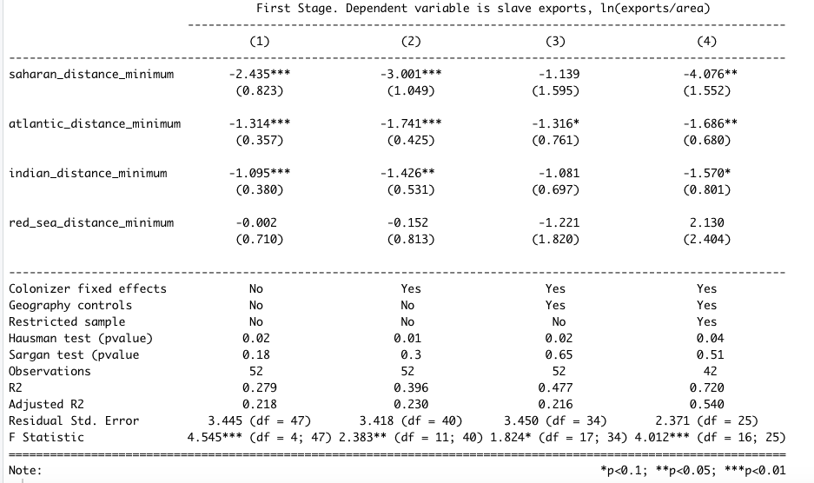

Similarly as before, in column (I) the model without controls, in column (II) the estimates with colonizer fixed effects, in column (III) the model with colonizer fixed effects and controls for geography, and in column (IV) the model without small islands and North African countries. Looking at the first-stage estimates, we can see that the further a country from the slaves demand, the smaller the size of slaves exports, with the exception of the Red Sea ports where the relationship is not significant and is positive in the last column.

As we can see from the second-stage, the estimates with this new methodology are bigger than the OLS ones. This is explained by the analysis on selection we did before, as selection was expected to bias the OLS estimates downward.

As we did before, we decided to run the model again by taking into account Heteroskedasticity-Consistent standard errors. Table IV reports the results.

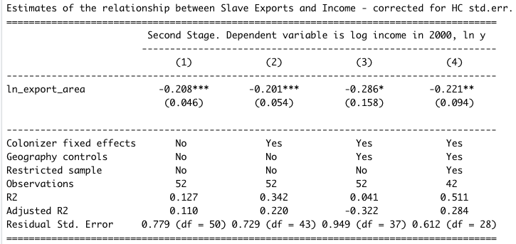

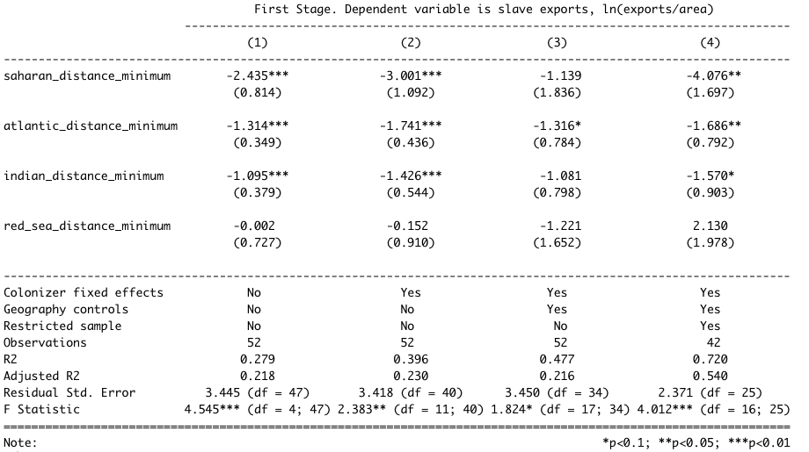

**4. Potential channels of interest**

Given these results confirming the author expectations, the author decides to further analyse and explain the potential channels through which slave trades could have affected the economic development. Given the small size of the sample, we can just try to look at data and explain what could have happened, but we cannot really measure those channels.

In the introduction of this paper, we mentioned that slave trades tended to have an impact on villages by weakening their relationship and causing a kind of fractionalization. If we look at figure III, we can clearly see that there is a relationship between slave trades and ethnic fractionalization, here measured following Alesina et al. (2003) [**CHeCK AND ADD SOMETHING ON THAT**}.

Figure III

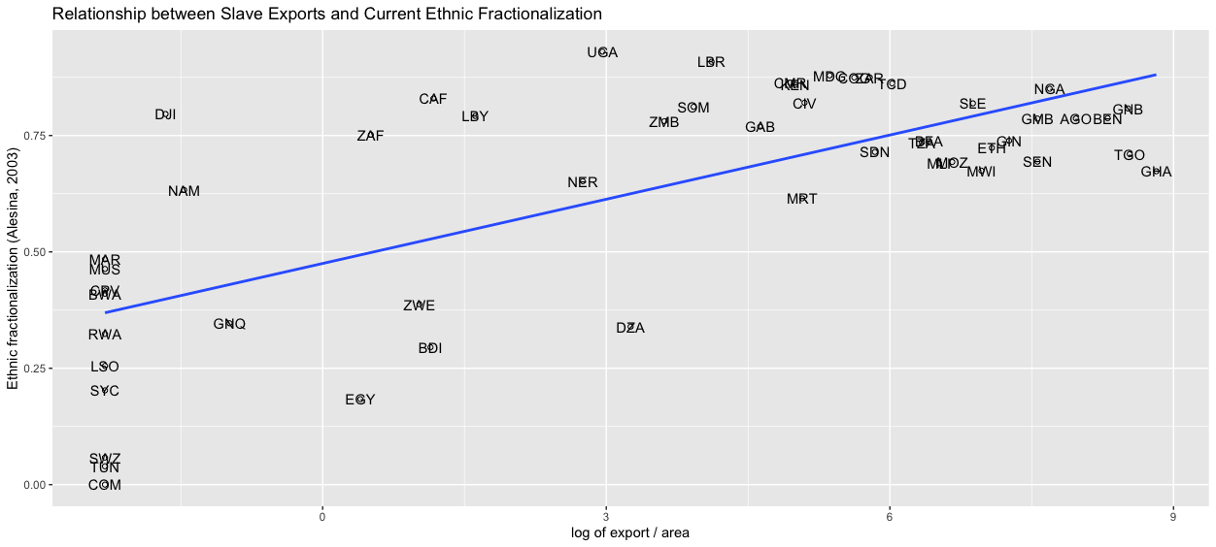

This channel is considered important by the author and supported by a wide literature suggesting that there is a relationship between ethnic diversity and economic growth because ethnic fractionalization impacts on key determinants of economic development (see Easterly and Levine (1997), Alesina, Baquir, and Easterly (1999), La Porta et al. (1999), Alesina et al. (2003), Aghion, Alesina, and Trebbi (2004), Easterly, Ritzan, and Woolcock (2006)).

Another important channel the author suggests is that slave trades weakens states’ development. To check for this channel, the author uses a measure of precolonial development suggested by Gennaioli and Rainer (2006). The relationship with slave exports is shown in figure IV.

Figure IV

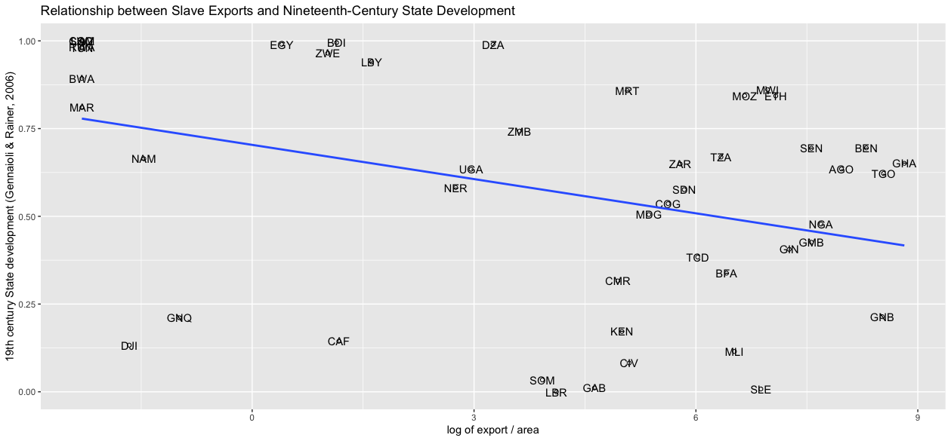

The visual inspection of figure IV confirms that there is a negative relationship between slave exports and states’ development. Again, literature suggests that a country history of state development is an important determinant for current economic performance (Bockstette, Chanda, and Putterman (2002), Chanda and Putterman (2005)).

5. New Methodology